Assignment 2
Multi-Layer Perceptron
Architecture and Optimization Experiments

Xander Palermo
Missouri State University
537 – Deep Learning
Mukulika Ghosh
6 March 2026

Introduction
For this assignment, we were prompted to develop a Multi-Layer Perception (MLP) Model using PyTorch or Tensorflow. This MLP additionally supports two modes: regression and binary classification. We were then instructed to test variable configurations to the structure of the MLP model and observe how these configurations affect the rate that these models find convergence, and the overall accuracy of the model when evaluating unseen data.
Methodology
The code for this assignment is separated into 3 files. All their specific implementation details are described below.
generator.py
This file generates the data to be used for training and testing the models used in the experiment trials. Each sample contains 10 features sampled from a 0 mean unit variance gaussian distribution. Since the assignment requires two separate “modes” of configuring an MLP network, the samples need different target data depending on the mode that the MLP network is set to. For regression targets, the following formula is used to create a non-linear function:
$$y=\sin\left(w^{⊤}x\right)+0.1{\left|\left|x\right|\right|}^{2}+ϵ;ϵ\sim N\left(0,0.1\right)$$
For Binary Classification targets, the following non-linear function was used:
$$y=I(sin\left(w_{1}^{⊤}x\right)+0.5 \left(w_{2}^{⊤}x\right)+ϵ>0); ϵ∼N(0, 0.1)$$
Where the symbol $I$ represents the binary nature of the function.
The generator function creates 2000 samples to be used for training and 500 samples for evaluation. For convenience, the samples are immediately imported to PyTorch’s DataLoader class, which shuffles the samples and divides them into batches of 64 samples. These DataLoaders can be given directly to the custom MLP class to train and evaluate.
MLP.py
This file contains the custom implementation of a PyTorch MLP model used for the experiments in this assignment. PyTorch was selected over TensorFlow, since it is the library that is used in the implementations of most of the components in the pipeline I put together for my final project. The custom class is very typical in terms of PyTorch implementations, and this is primarily because the introductory guide to creating this class from PyTorch’s documentation was used to give me a sense of direction. When creating the class, all input parameters are quickly checked for validity, and the model begins to dynamically construct itself according to the parameters given. Each hidden layer is of equal width of neurons, and the model is constructed by layering these hidden layers with activation layers until the number of hidden layers desired is reached (the output layer is then stacked on top). The class includes a basic forward propagation function too, as that is required implementation for each custom module. Finally, the class also includes a method for counting the number of trainable weights used in the model (useful for setting up experiments that need constant variables), and a predict function that can generate an inferred value based on given inputs. Since the guides I was using did not include a predicted function, I was unsure how to implement it further into the codebase, so it goes mostly unused.
Training Function
For the training loop, the algorithm first decides what loss function would be best for the given model (Cross Entropy vs. MSE) and begins to iterate through epochs. Each epoch, a batch of 64 samples is forward propagated through the model, and using the loss function, back propagation is used to adjust the weights of the hidden layers. The function also contains additional parameters that can be edited to change the outcomes we are observing in the model’s performance. The optional L2 Ridge weight decay can be used to adjust the amount that weights are penalized for containing values further from zero. The other optional parameter thresh can be used to implement a version of early stopping, saving on computational resources when the model is assumed to have found its convergence, and enables a safeguard against overfitting.
Evaluation Function
The implementation of the evaluation function is largely the same as the training function, just it only performs forward propagation and no backwards propagation to adjust the weights. Because of this difference, the optional parameters that contribute to how these weights are adjusted are also removed from this function. This function returns the overall performance of the model over every sample to preserve flexibility in the statical analysis of its performance. Additionally, in classification applications of the MLP network, the evaluation function will evaluate the accuracy of the model is able to classify samples with over the entire evaluation.
plotter.py
Each experiment directed by the instructions of the assignment are implemented in their own function. They test the following parameters in order: effects of activation function, hidden layer composition, optimization function, and L2 weight decay. To maintain consistency all parameters that are not the independent variable for these trials remain consistent and were selected for optimal training and declared at the top of the file. To increase the amount of data yielded by the experiment, each trial was run on a regression and classification version of the MLP, to also gauge if there was a difference in behavior when the context of use changes. Each function follows generally the same order of operations:
- Declare independent, and dependent variables
- Begin training and evaluating regression MLP models
- Print statistics to console of runtime to console and load loss function to pandas DataFrame
- Construct a plot using Seaborn and save to disk
- Repeat steps 2-4 for classification MLP models.
The last console output of plotter.py is saved to log.txt for review. For each experiment, the left figure represents the results generated by the regression model, and the right figure represents the classification model.

Experiments
Experiment 1
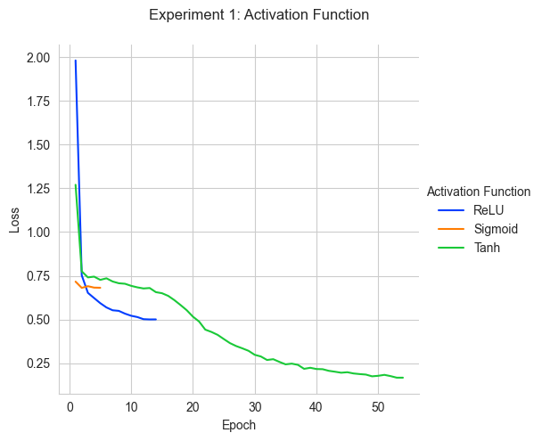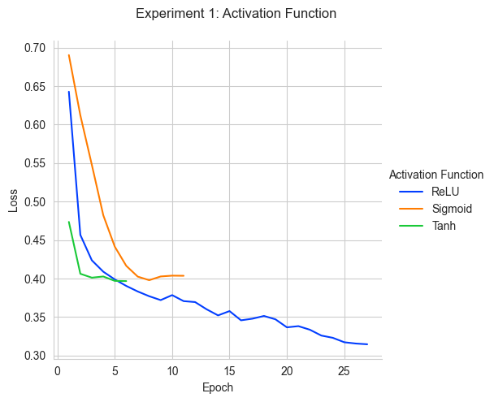
Objectives
The goal of this experiment is to determine how the activation function used in the architecture of the MLP network plays a role in its accuracy and rate of convergence. More specifically, this experiment also wanted to review the number of epochs required for each trial before conditions of early stopping are fulfilled. The ReLU activation function was selected as a constant variable for all other experiments, so I would like to see that this function has a good balance of speed of convergence and accuracy of the model.
Methodology
The functions tested in this experiment are sigmoid, ReLU, and Tanh activation functions. Each trial creates a new neural network with 2 hidden layers of 32 nodes each that implements the activation function selected. This process is repeated for both types of MLP networks used in this assignment. Learning rate is set to a 0.002 and the threshold amount is set to 0.001. The threshold is important to this experiment since it focuses on early termination. When the difference between the last epoch’s average loss and the current epoch’s average loss is less than the threshold value, early termination of the training loop is triggered.
Results
Overall, the results prove that there is a lot more variance in the speed of convergence than just the activation function, as they do not support any conclusion of correlation. The results of the classification part of the experiment also seem to me as more of an anomaly than concrete evidence of a conclusion. I can state that generally through observations tanh was able to generate models with the lowest amount of loss, and ReLU functions were able to come to the lowest amount of loss for the convergence is found (it generally has the largest slope in lower epochs). I found that through observation sigmoid functions would typically converge quickly, however it is at a minimum that has a higher loss than the other two activation functions. It is worth mentioning however that sigmoid function had the highest accuracy in classifying, with an 84% accuracy - which is better than the 83.4% for Tanh and 81.4 for ReLU. Tanh also had the fastest convergence after 6 epochs for this experiment. This could point out that the Tanh function got stuck in a local minimum, and the threshold value set was too high for the model to escape.
Experiment 2
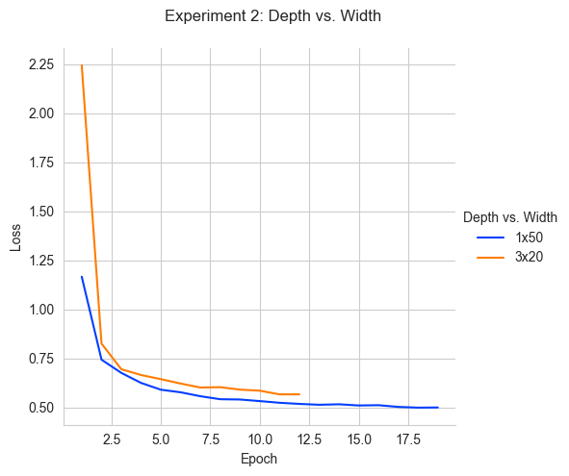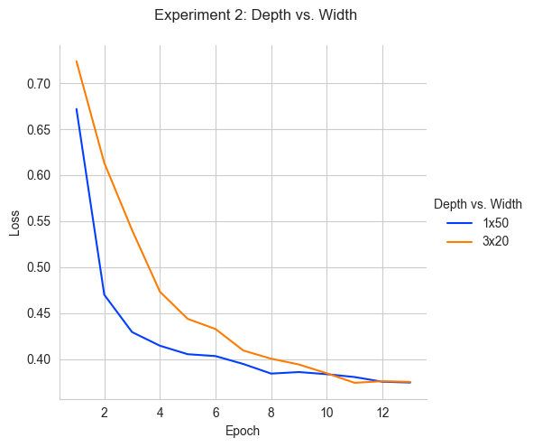
Objectives
This experiment asks to create two MLP networks with different compositions of hidden layers (changing the number of hidden layers and the number of neurons per layer). Because of the way that my MLP network constructor is coded, each hidden layer has the same number of neurons as every other hidden layer, so it leaves little room of testing a diverse range of compositions. Therefore, there are only two test groups selected for comparison, those being a very shallow but wide model, and a deeper and narrower model. From information given about this topic in class, a deeper network is preferred due to its greater ability to create more accurate results, and it’s for its efficiency since it requires easier computations for forward and backwards propagation.
Methodology
As stated before, there are only 2 test groups selected for this experiment, described by their depth x width. These groups are more extreme versions of the constant selected for the other experiments (being 2x32). An important note about the two groups used in this experiment is that these groups also have a different number of trainable parameters, meaning that some of the results could be skewed by this difference.
Results
The training results show some very interesting differences in the behaviors of the two compositions. It can be seen in the figures above that the shallower network (1x50), had faster approach to the convergence point than the deeper network, however, it still took longer than the deep network to find that point of convergence.
Experiment 3
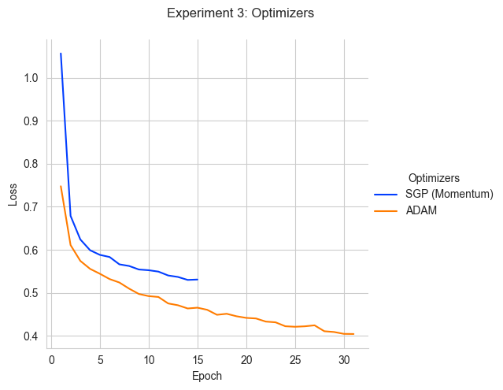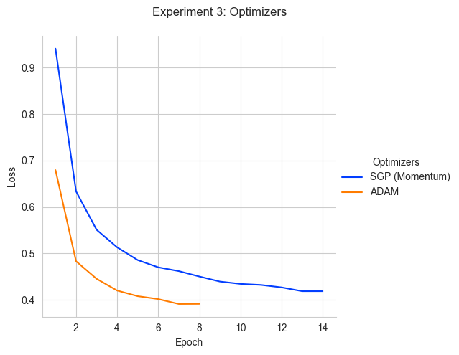
Objectives
In this experiment, the effect that an optimizer function has on the overall results generated by an MLP model. An optimizer is a newer topic that we have covered in class and relates to how we change the weights for features depending on where in training the model is. Typically, these optimizers will increase the learning rate in beginning stages of training and decrease it as a point of convergence is found. These optimizers can also assist in escaping troubling features on a gradient descent such as plateaus, as they can help accelerate the training speed of the model past these features.
Methodology
The two optimizers compared in this experiment are SGD with momentum, and ADAM, which is an adapted version of momentum that applies a unique learning rate to each weigh in the model.
Results
Overall, it is clear to say that using and ADAM optimizer outclasses the use of SGD with momentum. The classification that was using ADAM had a faster convergence (by half as many epochs), lower local minima in the loss function, and have a higher accuracy when used in the context of classification. These results were expected as well, as ADAM does take a few details of momentum and applies them to a more granular scale. As stated, ADAM applies its optimization to each trainable parameter in the network. This allows Adam to be more adaptive to the features of the loss function in respect to the weights and avoid problems that momentum typically have (such as jumping over a minimum from cliffs for example). However, the results of the regression model have a different story, as the momentum optimizer converged faster and has a lower average loss on testing data. This could imply ADAM having issues with overfitting and requiring stricter usage of early stop and regularization (the latter of which was absent from this experiment).
Experiment 4
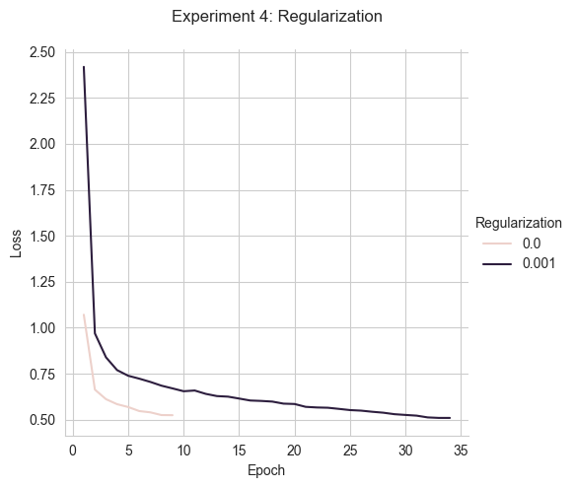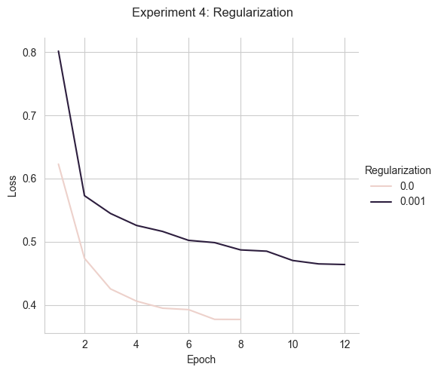
Objectives
This experiment is like an experiment completed in the first assignment, and it studies how weight decay has an impact on the results generated by a Neural Network (just in this case over an MLP rather than a linear network). This means that I am looking to observe a very similar conclusion to the original experiment, being that implementation L2 regularization does have a somewhat noticeable positive outcome on the results of the experiment
Methodology
Implementation of L2 was much different to the implementation of L2 in the first assignment. Since I am working with a library that I am not very confident with, I followed the implementation that I found in the documentation of PyTorch, however I am unclear if that is this is the correct application of I, and therefore believe that this could have some amount of impact on the results generated by this experiment. For all other tests, L2 is not utilized to ensure that this implementation does not affect the outcomes of other experiments.
Results
The results generated by this experiment could somewhat confirm my suspicions of a faulty implementation. You could also interpret this lower loss value and faster convergence as the fault of overfitting to the data, which does match up with the problems that L2 regularization is made to address. However, in terms of how these models performed on testing and evaluation, the model without L2 performed better with a slightly higher accuracy for classification and a slightly lower mean loss and standard deviation. This overfitting problem is likely solved by the threshold that I have been using as a constant parameter, as it is stepping in before the flaws of no regulation are fully exposed and preventing the overfitting that is characteristic of an implementation without it.
Conclusion
From these experiments, I have learned a lot about the implementations of how to use PyTorch to create MLP models, as well as how to train and evaluate them. The data that I generated for this report is a little unclear, and I believe that most of the variance in results comes from the randomness that is involved with weight initialization and stochastic batch training. However, through observation during debugging, I can claim that generally the figures produced by this report do follow the theories discussed in lecture. In future assignments I will consider the inclusion of control groups in the results of my experiments, to better interpret how these parameters have impact on Neural Networks in respect to the randomness they include.

